The Great Journal of (Name):_____________________________ Date:________________

The Voyage Journal: A Record of New Lands
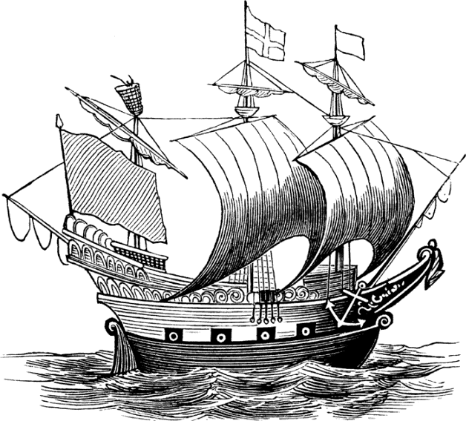
Much like Christopher Columbus (a.k.a. Cristoforo Columbo), you have convinced the King and Queen of a far away country to fund a voyage to the mysterious land of Meridian’s Central Academy (or your day school).
On your voyage, you are to keep a journal/diary. At a minimum, you need:
- Five entries
  - Each entry about 4-5 sentences
  - Each entry = one day
  - Focus on riches, converting the people (to a religion, way of thinking, etc.), and descriptions of the landscape.
- Be as specific as possible.
  - Note sights, sounds and smells with as many details as possible.
- You are writing for an audience that knows nothing about the place you are describing, and that audience could possibly be in the future (or distant past).
  - For example, they and you may have never seen a cell phone before.
- You need at least two illustrations or other decorations to enhance your writing.
  - The more creative, the better!

Example for ONE entry
September 15th, 2011
After hundreds of seconds of travel across the great stormy roads of Meridian, Idaho, I finally arrived to the great land of Meridian’s Central Academy. The crew, unfortunately, did not make the journey and I have arrived alone. I assure Your Majesties that I will accomplish my task of finding riches and converting the people to “the great religion” (whatever you decide that to be). Upon arriving to the cement shore of the school, I was greeted by an Academy native that wore many precious items, such as a glittering clock around his wrist made of pearl and silver. Noting its worth, I surveyed the rest of the Natives…

